Central Carolina ENT/
Wake Ear, Nose & Throat Specialists
Dr. Pankaj Gupta
1309 Carthage St, Unit A
Sanford, NC 27330
Phone: 919-774-6829
Fax: 919-776-3834
Website: www.WakeENT.com
REFERRAL FORM

‘FOCUSED ON CARE’
Date: _____________
Patient Name: ___________________________ Phone: _________________ Ins: _____________
Referring Physician: _____________________________ Practice Name: _____________________
Practice Phone Number: _________________________ Practice Fax Number: ________________
‘Focused on Care’ is more than our motto; it’s the way we practice medicine.

About Us:  At Central Carolina ENT/ Wake Ear, Nose and Throat Specialists, Dr. Gupta offers general ENT care and specializes in diseases of the ear, nose and throat with a focus on sinuses. He has advanced training in minimally invasive surgical procedures including those involving the thyroid and paranasal sinuses and offers in-house surgical sinuplasty.  We have a full-service audiology department which provides audiology care and treatment of patients with hearing loss and tinnitus.  We provide care to children and adults and accept most insurance plans.  Dr. Gupta also sees patients in Cary. | Tonsils, Adenoids or Ear Tube Consult  Evaluate Sinusitis / Nasal Complaints  Office Endoscopy (Nasal)  Office Endoscopy (Laryngeal)  Evaluate Thyroid Nodule  Evaluate Neck Mass  Head and Neck Fine Needle Aspiration  Other ___________________  ENT Audiology  Sudden Hearing Loss Hearing Loss  Tinnitus Hearing Aid Evaluation  Vertigo  Other ___________________

*Please fax over all patient notes pertaining to this referral.

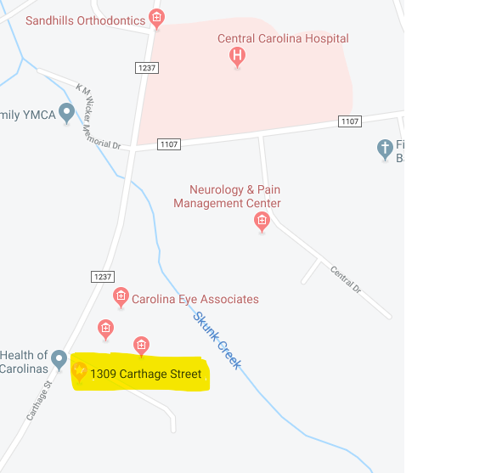
Turn onto Dennis Dr. from Carthage St. and an immediate right turn into our parking lot. We are at the end of the building.

Conveniently located in Sanford with easy access from surrounding areas

